****BEHAVIOUR SUPPORTS ALGORITHM (Toronto Central Region)

= BSO Coordinating Office

Primary Support:

* GEM Nurses
* Hospital Team
* Specialist consults

**ACUTE CARE**

Increasing Supports:

* Embedded Hospital BSS
* UHN BSS
* LOFT BSTR
* BSOT ED (HCCSS)
* BSOT Transition Support

Increasing Supports:

* BSOT
* GMHOT
* PRC
* BSOT NP
* Addictions Specialist
* AST Caregiver Specialist
* LTC+
* BSOT Transition Support

Increasing Supports:

* BSOT
* CPOT
* PRC
* Geriatric Medicine
* BSOT NP
* COPA
* COSS
* BSOT Transition Support

Resolved?

YES

NO

Behaviours Remain Unmanaged

Virtual Behavioural Medicine Consultation Program (VBM)

Resolved?

NO

YES

Primary Support:

* Primary Care Physician/ Team
* Care Coordinator, HCCSS
* Community Partner agencies, Case Manager
* AST Navigator

Primary Support:

* LTCH staff
* LTCH physicians
* In house BSO Lead

If **resolved** at any of 3 points above, return to primary supports

Complex Case Resolution Table (CCRT)

YES

NO

NO

Urgency/ Hospitalization?

CASS Bed/TBSU

Not Resolved

Not Resolved

YES

Urgency/ Hospitalization?

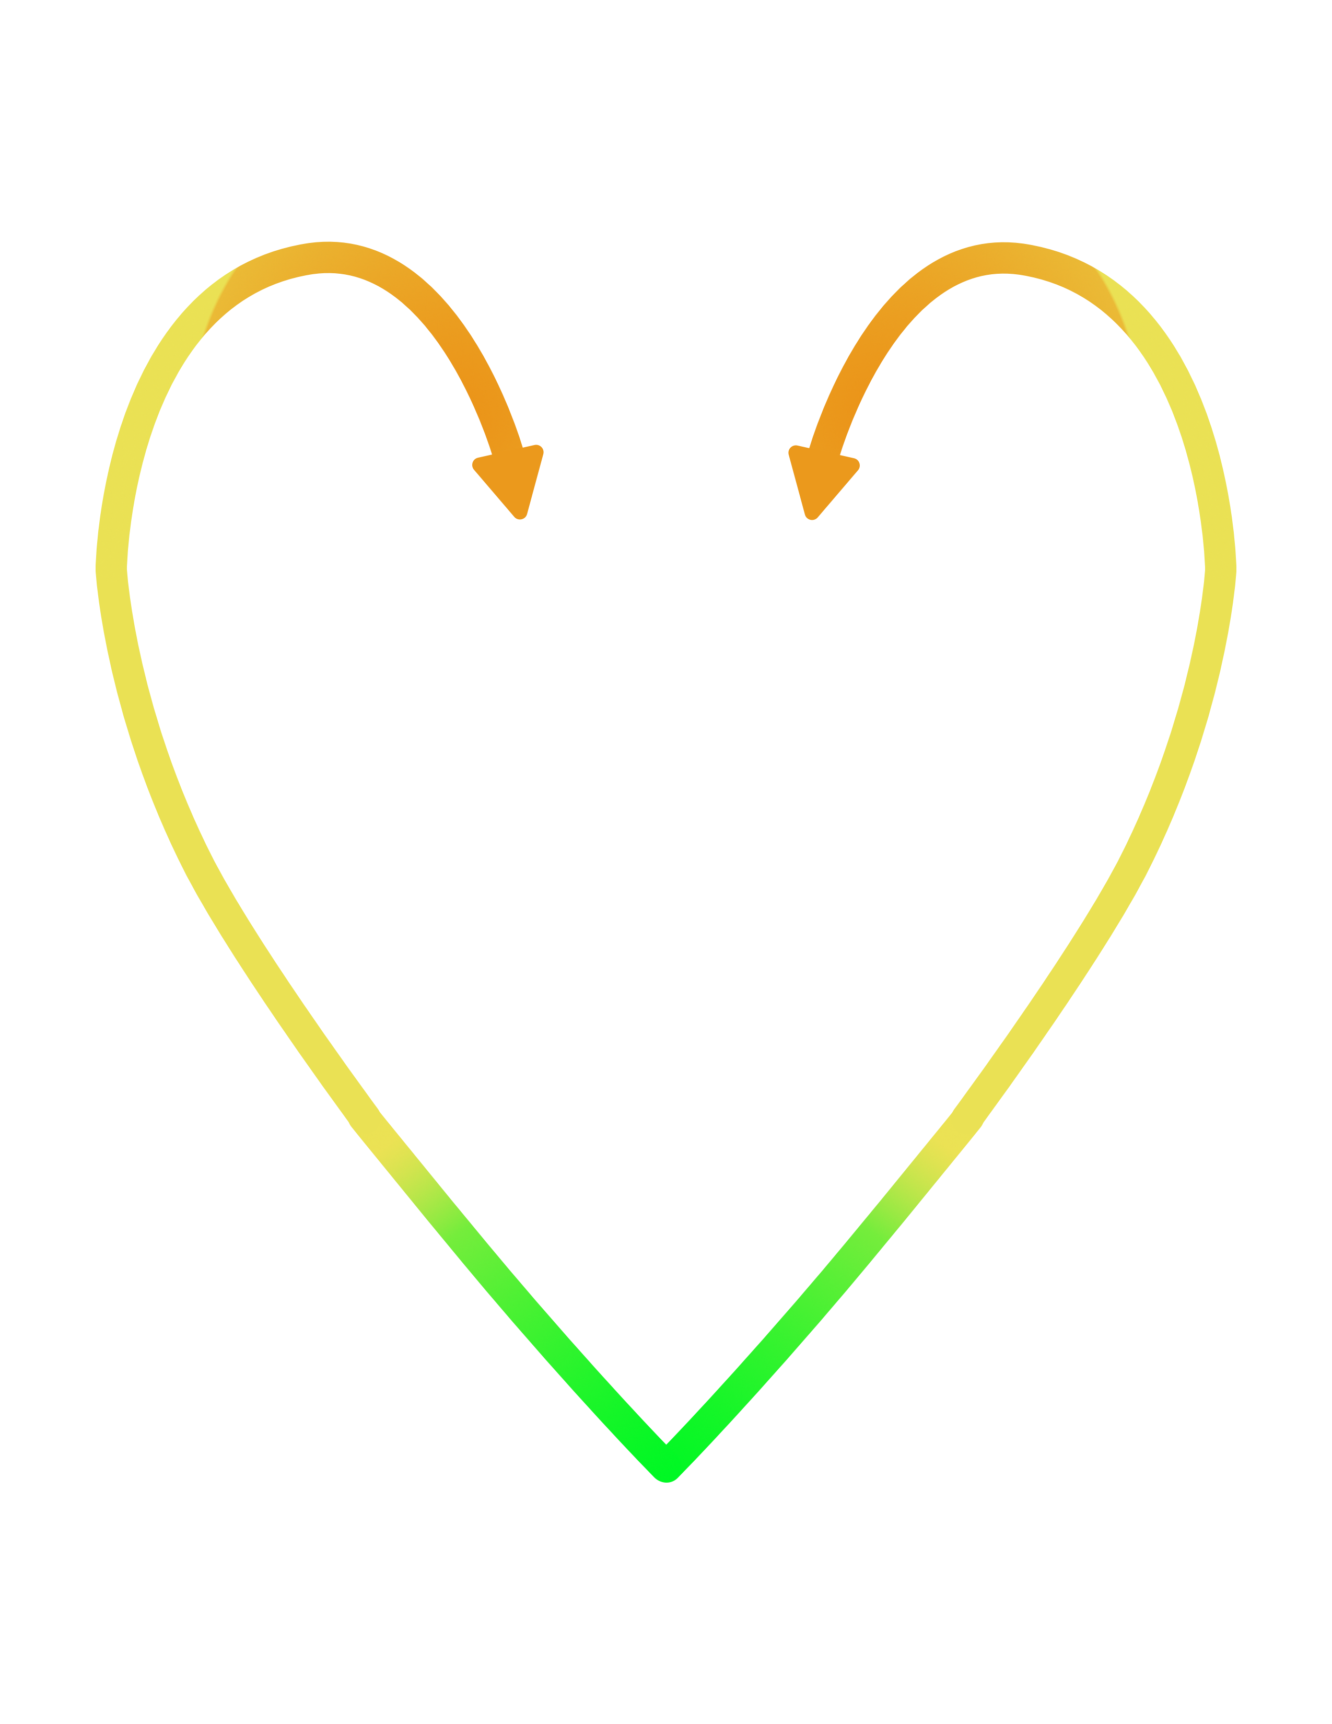

**COMMUNITY**

**LTC**

**Acronym Glossary:**

**LONG TERM CARE (LTC) SECTOR**

* LTCH: Long Term Care Home
* BSO Lead: Behaviour Supports Ontario Lead (works within LTCH)
* BSOT: Behaviour Support Outreach Team
* GMHOT: Geriatric Mental Health Outreach Team
* PRC: Psychogeriatric Resource Consultant
* AST: Alzheimer’s Society of Toronto
* LTC+: Long Term Care Plus - Virtual Care Program
* BSOT NP: Behaviour Support Outreach Team – Nurse Practitioner



**Escalation Options (for all sectors)**

* CCRT: Complex Case Resolution Table
* VBM: Virtual Behavioural Medicine Program
* TBSU: Transitional Behavioural Support Unit (located in LTC)
* CASS: Centralized Access to Seniors Specialty Hospital Beds (located in Acute Care)

**ACUTE CARE SECTOR**

* GEM Nurse: Geriatric Emergency Management Nurse
* BSS: Behaviour Support Specialist
* UHN BSS: University Health Network – Behaviour Support Specialist
* LOFT BSTR: Leap of Faith Together – Behaviour Support Transition Resource
* BSOT ED: Behaviour Support Outreach Team - Emergency Department

**COMMUNITY SECTOR**

* HCCSS: Home and Community Care Support Services
* AST: Alzheimer’s Society of Toronto
* BSOT: Behaviour Support Outreach Team
* CPOT: Community Psychogeriatric Outreach Team
* PRC: Psychogeriatric Resource Consultant
* COPA: Community Outreach Programs in Addictions
* COSS: Crisis Outreach Service for Seniors
* BSOT NP: Behaviour Support Outreach Team – Nurse Practitioner